EMBEDDED SYSTEM AND DESIGN
EXPERIMENT NO. 6

SELF-DRIVING CAR

Name: Raphael S. Nano

Course/Section: CPE161P / A1

Date of Performance: January 4-5, 2023
Date of Submission: January 6, 2023

Ma'am Cyrel Manlises
Instructor

DISCUSSION

Automotives are one of the most important inventions in a world of busy transportation. They are examples of integrated embedded systems, wherein several parts of automotives contain embedded systems. With the developments in technologies, remote-controlled vehicles became possible. Internet, Bluetooth, and many more wireless technologies allowed the control of vehicles from afar in order to transport people or items. With that said, a self-created car was developed, wherein its movement, such as forward, backward, left, and right, can be controlled using an infrared remote as Arduino UNO as its base of program.

The objectives of this experiment are as follows:
1. To demonstrate how a self driving car works (Forward, Backward, Right, and Left).
2. To be able apply what you have learned in logic circuits and switching theory, microprocessors, and CPE160P.
3. To be able to apply real-time embedded system using Arduino kit.

The materials utilized for this experiment include the Arduino Uno, the infrared remote, TSOP1838 IR receiver sensor, 2 wheels, 2 DC motors, L298N driver module, and a car chassis.
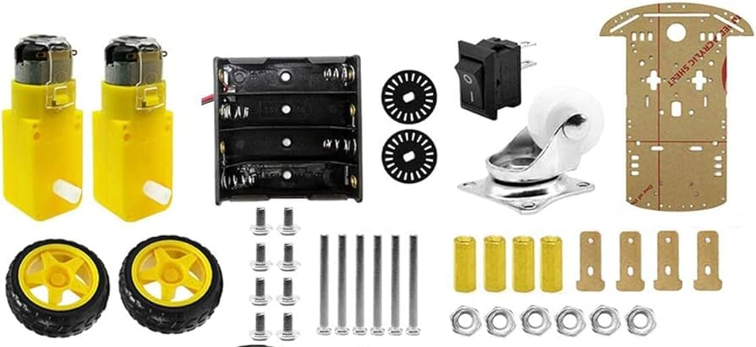

Figure 1. Major Components for the Experiment

For the external library, the IRremote.h was the only library utilized in order to command the infrared remote.
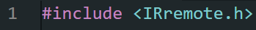
Figure 2. External Library Included

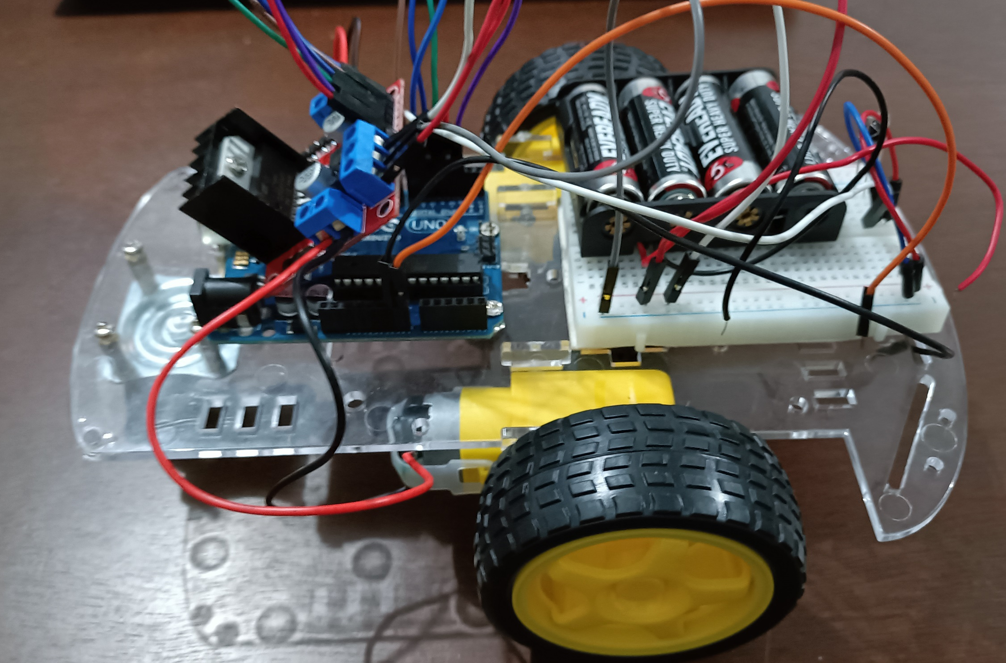
The primary objective for experiment 6 is to replicate a self-driving car that operates in real-time. The IR remote will be used as the controller, wherein it includes the control to every direction of motion (e.g., forward, backward, left, right). The operation simply activates the DC motors and adjusts the power of motion, depending on the number pressed on the remote.

Figure 3. Final Output of the Experiment
An optimized switch case inside a remote() function was utilized to determine the value of the button pressed in the remote. Using the function IrReceiver.decodeIRData.command, the values were obtained experimentally. For button 2, an integer of 24 is decoded, 8 for button 4, 90 for button 6, and 82 for button 8.
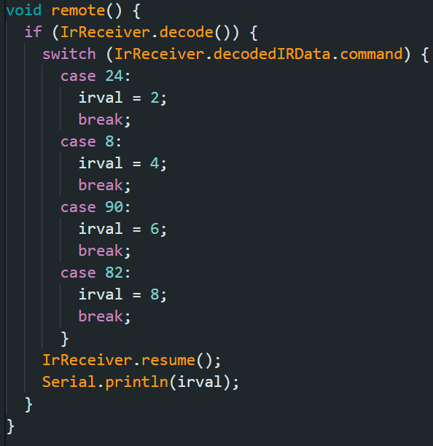

Figure 4. Switch Case for IR receiver

Basically, in1 and in2 are outputs to the left DC motor, and in3 and in4 are outputs to the right DC motor. Enabling ENA and ENB is done to activate both DC motors. Separate functions were developed as a shortcut to digitalWrite and analogWrite. ond was used for the HIGH digitalWrite, offd for LOW digitalWrite, ona for 255 analogWrite, and offa for 0 analogWrite.
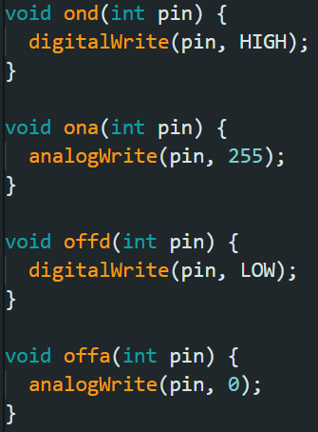

Figure 5. Shortcut Functions

Since button 2 is assigned to the forward motion, the car continuously moves forward as long as button 2 is pressed. Same with button 8, the car will continue to go backward as long as it is pressed.

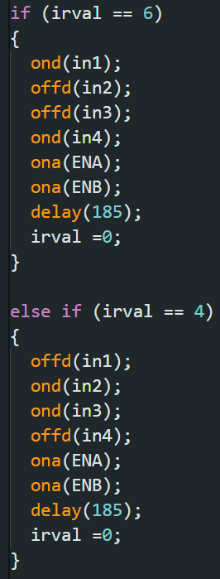
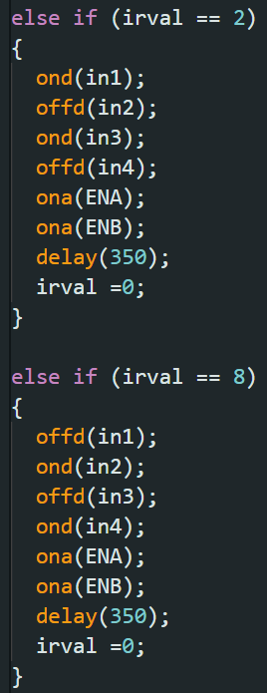

(b)
(a)
Figure 5. (a) Code for Forward and Backward motion. (b) Code for turning right and left

Same concept is applied for buttons 4 and 6, which are used for turning left and right, respectively. Buttons 2, 4, 6, and 8 were used so that it would easily represent the directions up, down, left, and right, considering their positions on the remote.

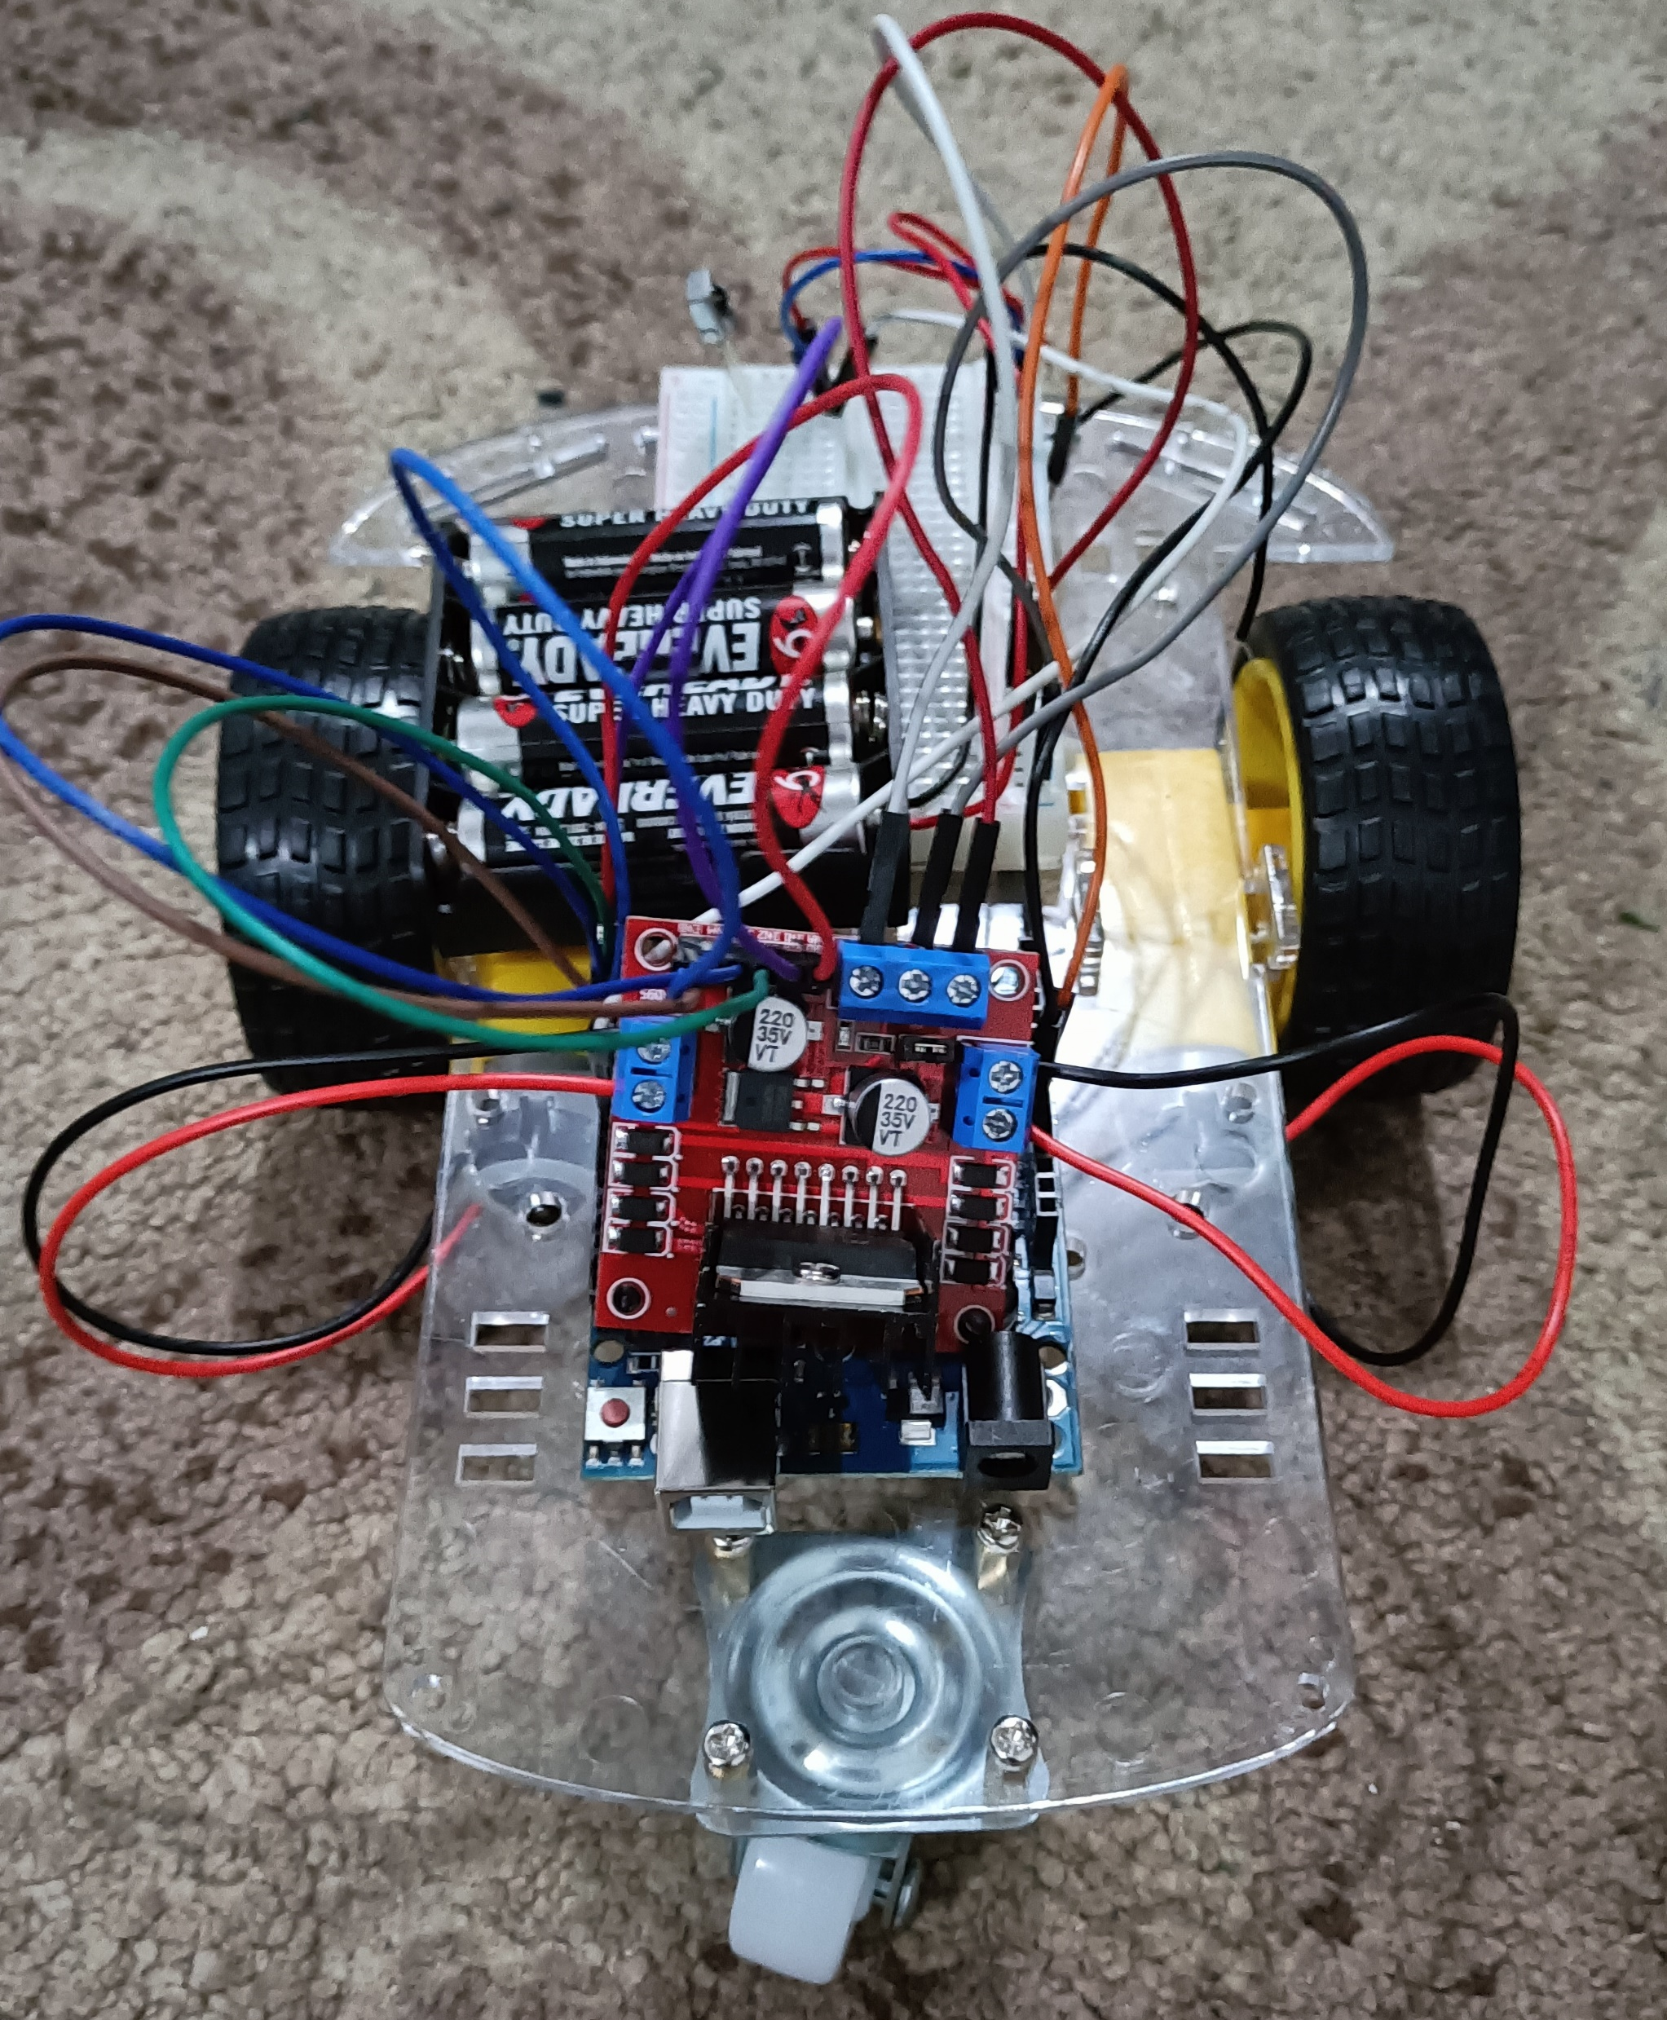
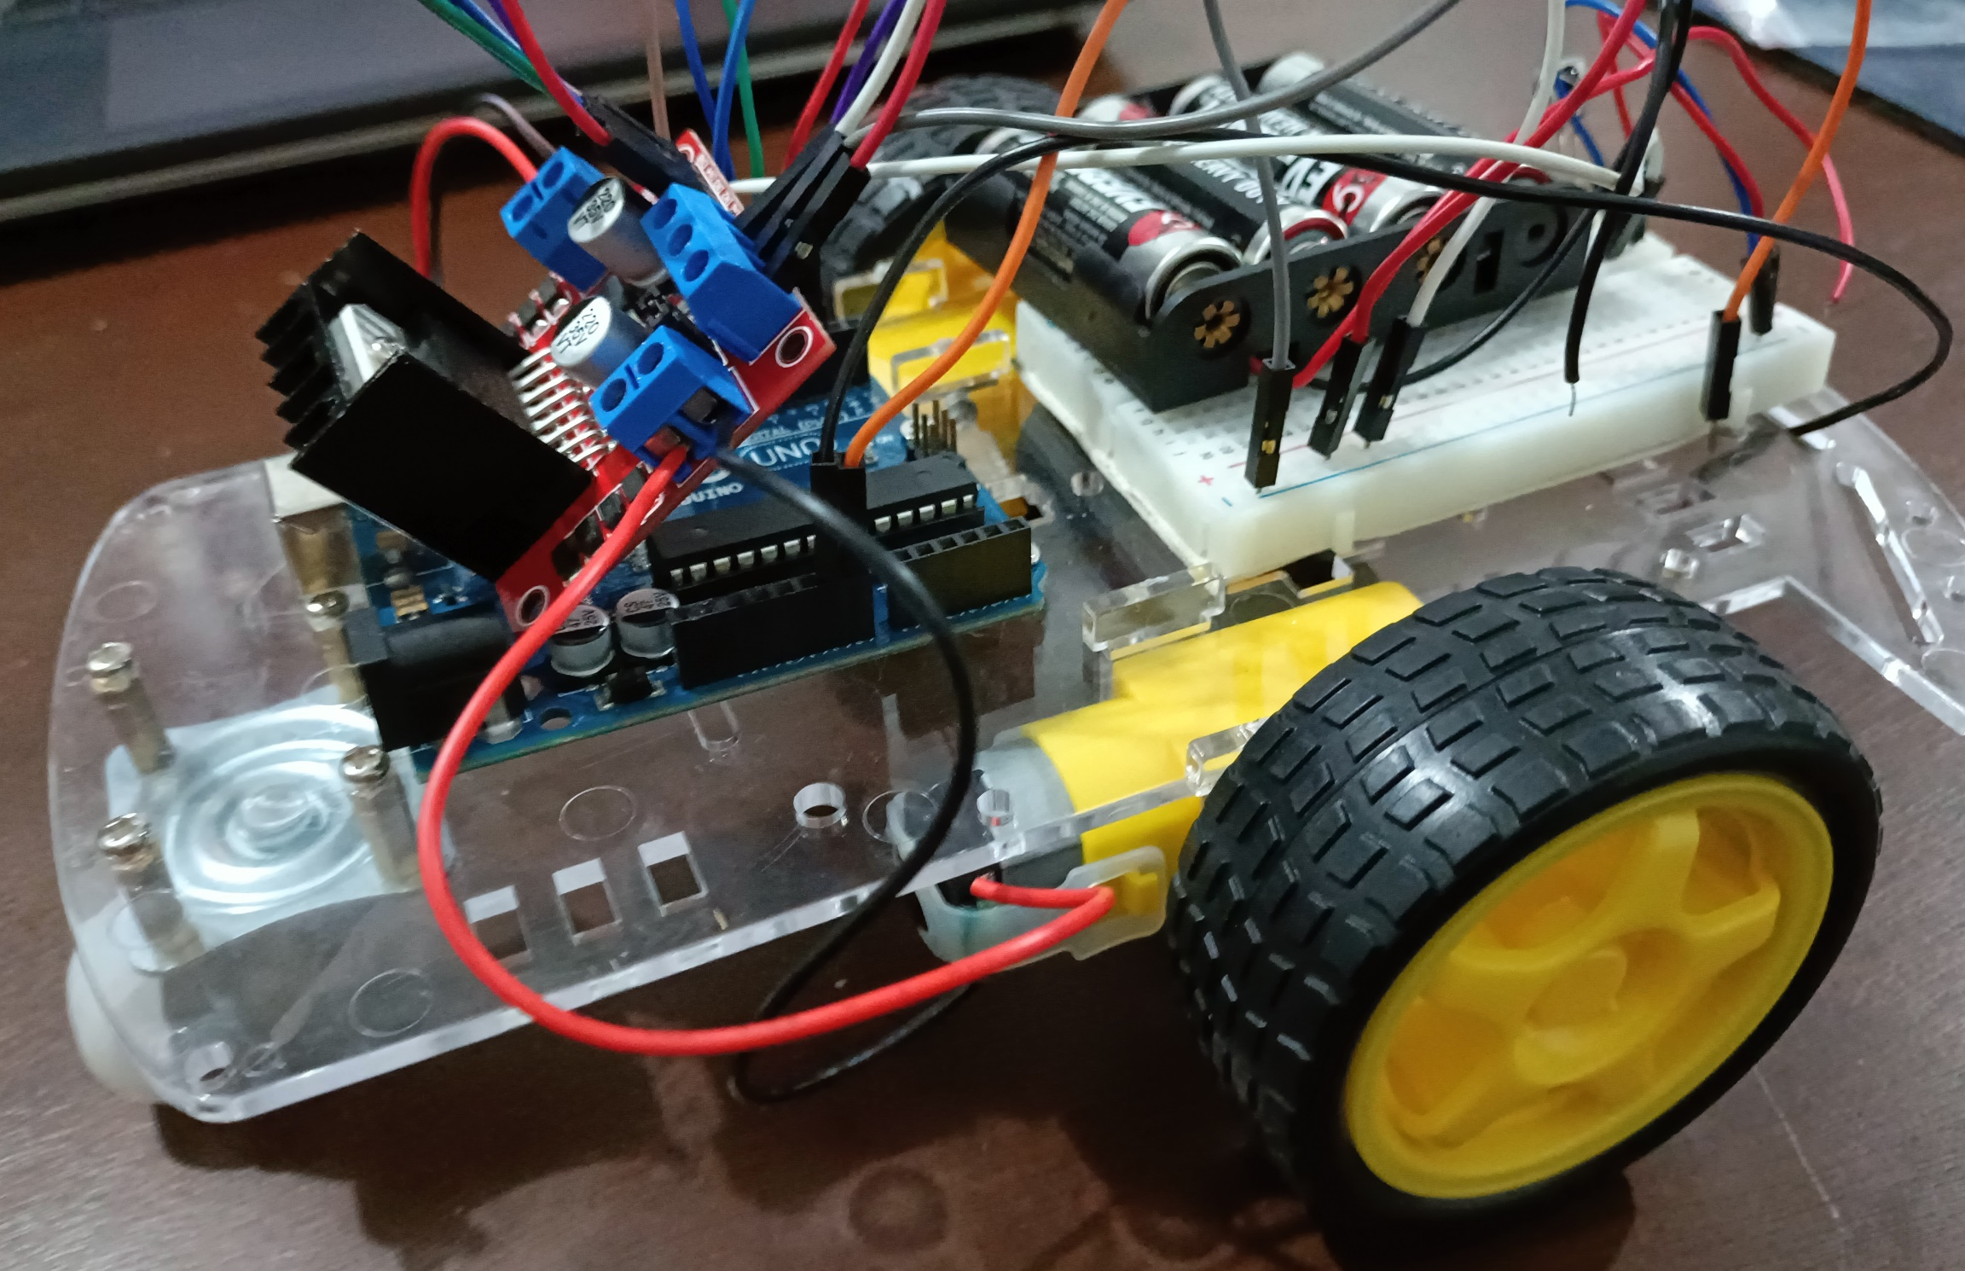
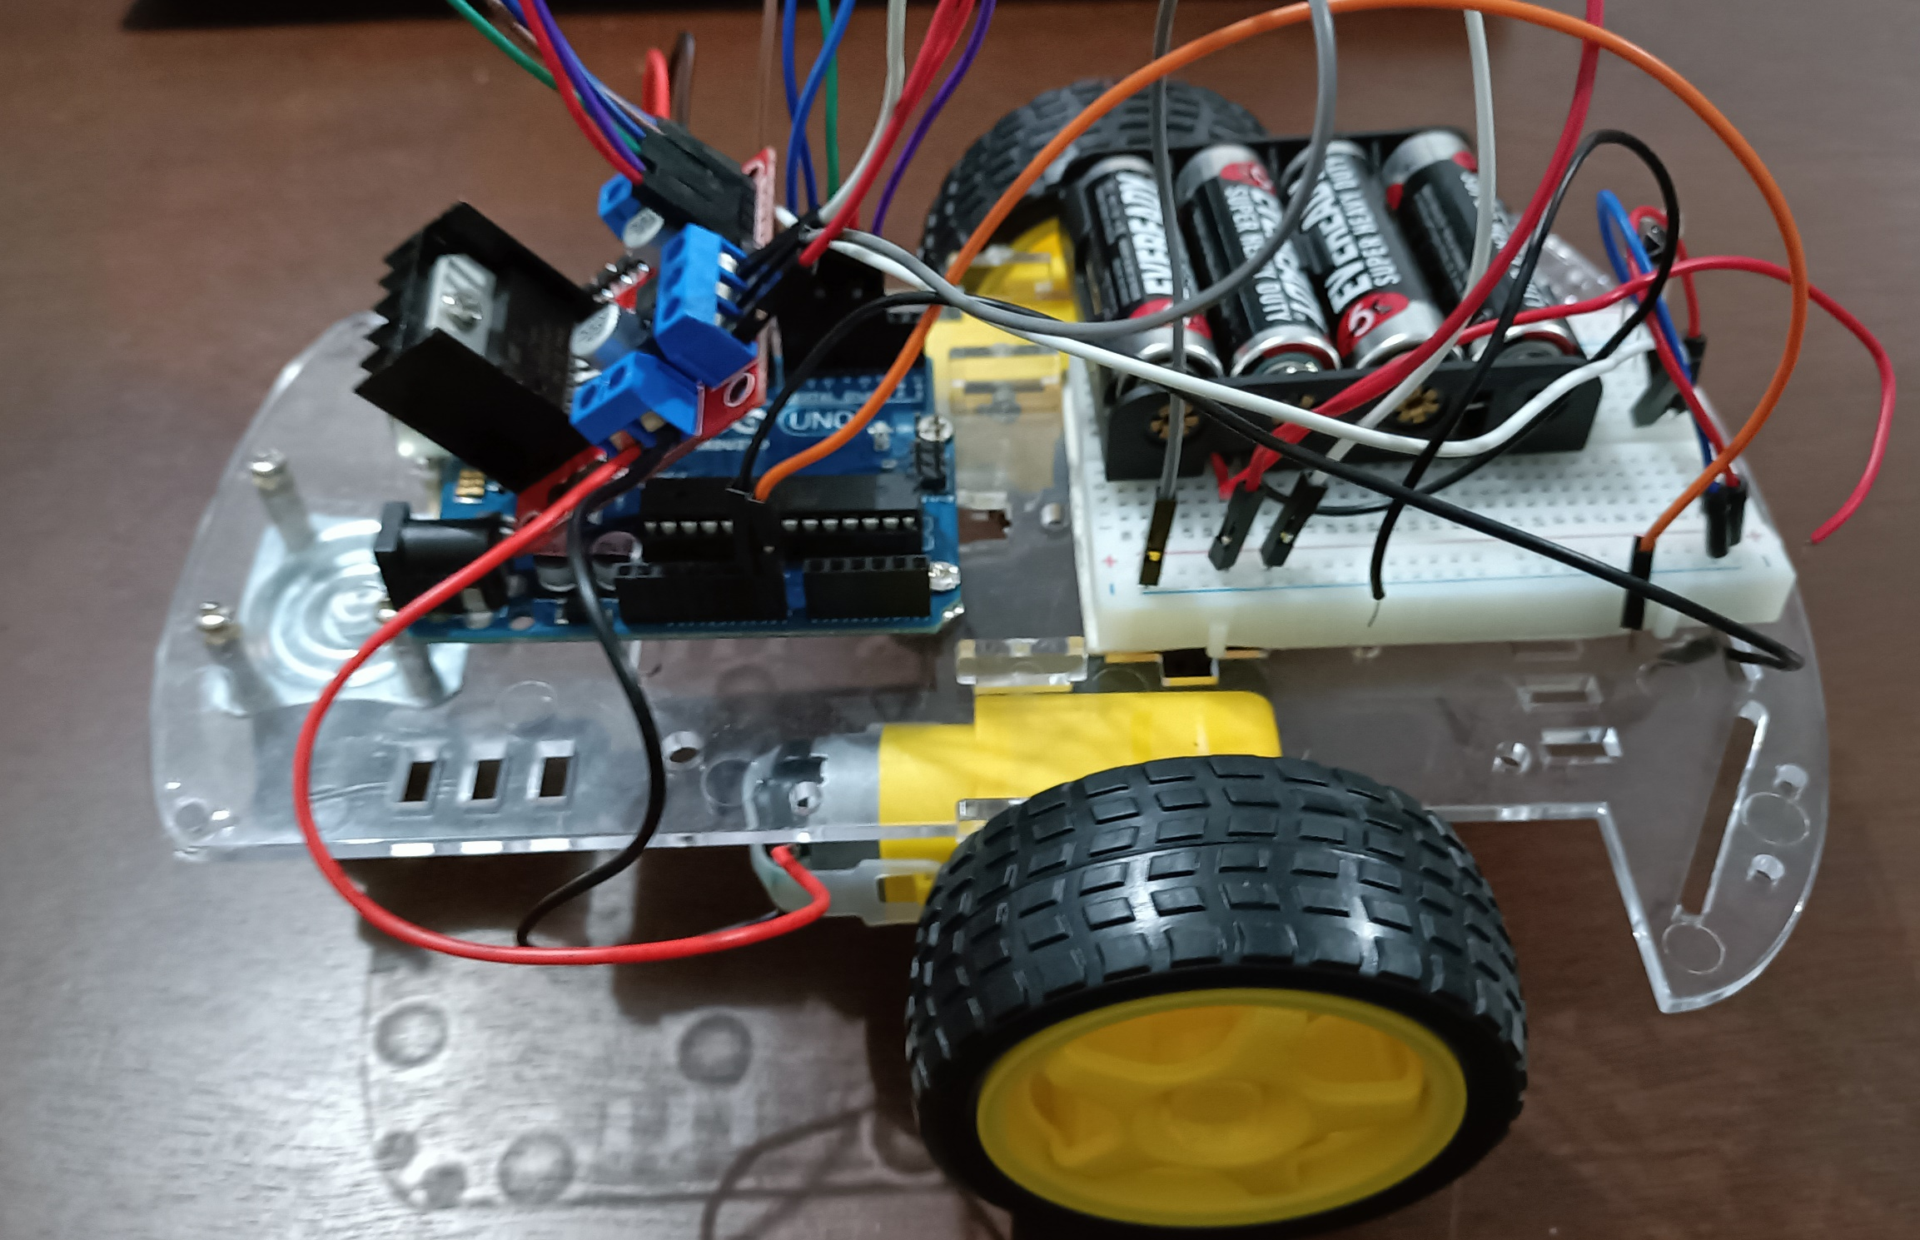
(c)
(b)
(a)
Figure 6. Final Output of Experiment 6
CONCLUSION
To conclude, for the first objective, all directions of motion were successfully demonstrated through the use of buttons 2 and 8 for the forward and backward motion and buttons 4 and 6 for turning left and right. The second goal was reached by synchronizing the IR remote with the L298N driver module and DC motors, which demonstrated the use of microprocessors, logic circuits, and switching theory, as well as the teachings in CPE160P. The self-driving car was successfully created utilizing the Arduino kit and car chassis kit, and basic handshaking was proven by synchronizing the input and output in real-time.

